Smart Railway Gate Control System using IoT for Enhanced Safety

Mr. K Pradheep Assistant Professor,
Department of Electrical and Electronics Engineering
KIT-Kalaignarkarunanidhi Institute of Technology, Coimbatore ,India.
pradheee@gmail.com
Manasha M Department of Electrical and
Electronics Engineering KIT-Kalaignarkarunanidhi Institute of Technology, Coimbatore ,India. kit27.eee032@gmail.com

Dayanban R V Department 0f Electrical and
Electronics Engineering
KIT-Kalaignarkarunanidhi Institute of Technology,Coimbatore ,India. kit27.eee009@gmail.com
Aswin S Department 0f Electrical and
Electronics Engineering KIT-Kalaignarkarunanidhi Institute of Technology, Coimbatore ,India. kit27.eee005@gmail.com

ABSTRACT- Railway crossings are among the most dangerous points in railway networks, where accidents often happen due to human mistakes or delayed gate operations. To solve this issue, the project “Smart Railway Gate Control System Using IoT for Enhanced Safety” introduces an automatic and intelligent railway gate system. The system uses ultrasonic sensors placed about 200 meters away from the gate on both sides of the track to detect the arrival and departure of trains. When the first sensor detects a train, the ESP8266 Wi-Fi module sends real-time data to the Blynk application, which notifies users that the train is approaching. The servo motor automatically closes the gate to ensure safety for vehicles and pedestrians. After the train crosses the second sensor, the system reopens the gate and sends another notification through the Blynk app confirming that the train has safely passed. This IoT-based automation reduces human involvement, increases accuracy, and ensures timely gate operation. The proposed system provides an efficient, low-cost, and reliable solution for improving safety and preventing accidents at railway level crossings.

Keywords - IoT, ESP8266, Ultrasonic Sensor, Smart Railway Gate, Blynk App, Automation, Safety System.

INTRODUCTION
Railway crossings are critical points in the railway network, where road traffic and train tracks intersect. Managing these crossings safely is essential because any delay or error can lead to serious accidents. In India, where road and rail traffic are both heavy, accidents at level crossings are common, often caused by delayed gate operation or the lack of timely warnings. One notable incident, the Cuddalore train accident, highlighted how insufficient monitoring and slow communication can result in Severe accidents. These challenges emphasize the need for an intelligent system that can manage railway gates efficiently and provide real-time alerts to prevent accidents.
The proposed project,"Smart Railway Gate Control System Using IoT for Enhanced Safety" introduces an automated solution that combines sensors and IoT technology to operate gates safely and efficiently. Ultrasonic sensors are installed about 200 meters away from the gate on both sides of the track to detect the approach of trains. When a train passes the first sensor, the system immediately identifies its arrival and sends a real-time notification that "the train is approaching the gate "through the Blynk app, alerting nearby vehicles and pedestrians. At the same time, a buzzer is activated to ensure everyone is aware of the approaching train.
After the train passes the second sensor, the system recognizes that it has completely crossed the gate. The buzzer stops, and the Blynk app sends another notification confirming that "the train has crossed the gate",that ensures it is safe to cross. This fully automated system reduces human error and provides real-time monitoring. By integrating IoT technology and instant notifications, the system enhances safety, reliability, and efficiency at railway crossings, providing a smarter and safer environment for both pedestrian and railway authorities.

LITERATURE SURVEY
This paper proposes an intelligent and automated railway gate control system that uses IoT sensors and microcontrollers to detect approaching trains and control the gate movement automatically. The system ensures safety by closing the gate when a train is detected and reopening it once the train passes, reducing human error and delay [1]. This paper introduces an IoT-based railway gate crossing system that works through ultrasonic sensors connected to an Arduino controller. The gate is operated by a servo motor, while a buzzer provides alerts for nearby vehicles and pedestrians [2].
This paper introduces a smart farming method that uses drones with artificial intelligence to find plant diseases in

crops. The drone takes pictures of the fields and checks them to spot any signs of infection. This system helps farmers watch over large areas easily, saves time and effort, and allows them to protect their crops more effectively.[3] This paper tells about an automatic railway gate system with a GSM alert that sends warning messages to nearby stations and users for real-time communication and accident prevention [4].
This paper shows that uses IoT and wireless sensors to detect train movement and control gates automatically. It focuses on improving reliability and connectivity, especially in rural areas [5].
This paper proposes an automated railway security system that uses infrared sensors and IoT modules for continuous monitoring and safety control through a central unit [6].This paper introduces a sustainable automated gate control system powered by renewable energy, ensuring continuous operation and safety even in power outages [7]
This paper shows how ultrasonic sensors and Arduino Uno can automatically detect train movement and operate the gate without human effort [8]. This paper proposes a fully automated and unmanned railway crossing system using IoT for signal communication and vehicle alerting, creating a complete automation environment [9]. This paper tells about an adaptive observer-based fault detection system designed for high-speed railways, which maintains safe control even if a sensor fails [10].
This paper demonstrates the design and fabrication of a prototype railway gate controller using servo motors and Arduino. The system is affordable, easy to build, and suitable for developing regions [11]. This paper explains how fault testing methods are used in railway signaling systems to detect and fix possible errors before real-time operation [12].
This paper reviews a GPS-based railway crossing system that uses satellite tracking to detect trains and automatically operate gates [13]. This paper presents a traffic management system at railway crossings using IoT to control both vehicle and train movement efficiently, reducing congestion and accidents [14].
This paper explains an IoT-based level crossing gate system that combines ultrasonic sensors, Wi-Fi modules, and a buzzer for automatic gate operation and remote monitoring [15].
This paper presents an IoT-based railway security system for automated monitoring and control of level crossings through remote access [16].
This paper explains how a microcontroller can automatically open and close railway gates using sensors placed near tracks. It helps reduce human errors and delays caused by manual operation. The system improves safety and prevents accidents at railway crossings.[17]
The project uses IoT sensors and a microcontroller to control railway gates automatically. It connects to the
internet for real-time monitoring and alerts. The system ensures quick gate operation when a train is detected and enhances public safety.[18]
This research studies the use of IoT in railway safety systems. It uses sensors and Wi-Fi modules to detect trains and control the gate automatically. The system also sends alerts to users’ devices to prevent accidents.[19]
The paper presents a solar-powered system for automatic gate operation. It uses sensors to sense the train’s movement and runs on renewable energy. This makes the system energy-efficient, eco-friendly, and suitable for remote areas.[20]
Finally, This work proposes a sensor-based system that detects approaching trains and closes the gate automatically. It focuses on reducing manual work and avoiding accidents. The system also includes alarm and signal lights for extra safety.[21]
Traditional railway gate systems have primarily relied on manual operations, where a gatekeeper closes and opens gates based on schedules or visual spotting of the train. While simple, this approach often results in human errors, delayed responses, and no way to alert pedestrians and vehicles far from the crossing. To improve this, semi- automatic systems using sensors like infrared or ultrasonic have been introduced. These systems detect approaching trains and automatically close gates while activating buzzers to warn people nearby. However, these systems still have limitations such as local-only alerts, no remote monitoring, and dependency on sensor accuracy and fixed train timings. Any misreading or sensor failure can lead to malfunctions, compromising safety.

KEY CONTRIBUTIONS:

Smart Automation
The system automatically controls railway gates using IoT and sensors, removing the need for a gatekeeper.

Accurate Train Detection
Ultrasonic sensors detect the train’s arrival and departure in
real time, ensuring timely gate closure and opening.

Real-Time Alerts
The ESP8266 Wi-Fi module and Blynk app provide instant notifications to nearby users about train movement and gate status.

Enhanced Safety
The buzzer and live alerts warn vehicles and pedestrians, reducing human errors and preventing accidents.

Low-Cost and Energy-Efficient Design
The system runs on a simple 5V power supply and can even be powered by solar energy for rural areas.

Reliable Communication
IoT-based monitoring allows remote observation and control of gate status through the internet.

Scalability and Future Scope
The design can be easily upgraded with GPS, cameras, or cloud data storage for wider smart transportation use.

PROPOSED METHODOLOGY
The proposed IoT-based automatic railway gate control system is designed to monitor train movements in real-time and operate a railway crossing gate automatically without human intervention. The system contains two ultrasonic sensors to detect the train’s approach and departure, a NodeMCU ESP8266 microcontroller for decision-making and communication, a servo motor to control the gate's physical movement, and a buzzer to provide audio alerts to nearby vehicles and pedestrians. The first ultrasonic sensor is positioned approximately 50 cm before the gate to detect an approaching train. When a train is within range, the NodeMCU processes the distance measurement and immediately triggers the buzzer while sending a real-time update to the Blynk IoT app indicating that the “Train is approaching the gate”. Simultaneously, the gate is closed automatically using a servo motor. Once the train has crossed the gate, the second ultrasonic sensor—placed about
30 cm past the gate—detects the train's exit. When the sensor no longer detects the train, the NodeMCU deactivates the buzzer, reopens the gate via the servo motor, and updates the Blynk app with the message “Train has crossed the gate”. This real-time data transmission is made possible by the built-in Wi-Fi capability of the NodeMCU, which continuously sends sensor status to the Blynk cloud server. The entire setup operates on a standard 5V DC supply, either from a USB adapter or a power bank, making the system energy-efficient and suitable for deployment in remote or unmanned railway crossings. This architecture ensures reliable gate automation with real-time notifications, lower maintenance, and enhanced safety by preventing vehicle-train collisions at level crossings.

- BLOCK DIAGRAM:
This block diagram shows how the Smart Railway Gate Control System works using the ESP8266 module. The ultrasonic sensor detects the train’s movement and sends the signal to the ESP8266. The micro servo motor automatically closes or opens the gate, and the buzzer gives an alert sound when the train approaches. The Blynk app server sends real- time notifications through Wi-Fi to nearby users. This system helps to prevent accidents and improve railway crossing safety.

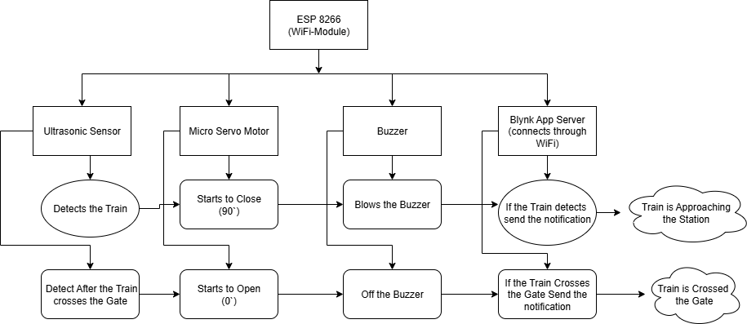
Fig 1: BLOCK DIAGRAM

A.ESP 8266
Figure 2 illustrates ESP8266 is a small and low-cost Wi-Fi module made by Espress if Systems. It allows devices like Arduino to connect to the internet using Wi-Fi. The module has pins to easily connect sensors and other electronic components. It can work as a Wi-Fi client or as an access point for communication. It consumes very little power and runs on a 3.3V supply. ESP8266 is widely used in IoT projects such as smart homes, automation systems, and smart railway gate systems.
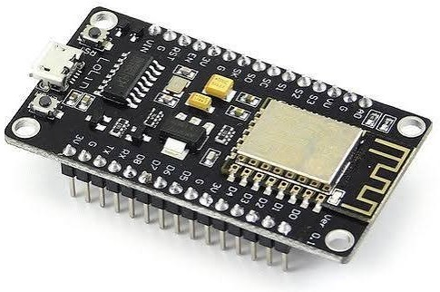
Fig 2: ESP 8266

B.ULTRASONIC SENSOR

Figure 3 illustrates An ultrasonic sensor is an electronic device that measures distance using sound waves. It sends out high-frequency sound pulses and detects the echo that bounces back from an object. By calculating the time taken for the echo to return, it can determine how far the object is.

Ultrasonic sensors are commonly used in robotics, automation, and smart systems for obstacle detection, level measurement, and distance sensing.
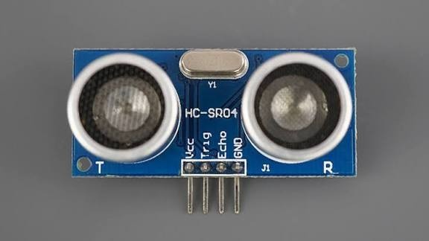
FIG 3: ULTRASONIC SENSOR

C.SERVO MOTOR
Figure 4 illustrates A servo motor is a motor that can rotate to a specific angle very accurately. It has three wires: power, ground, and control .The control wire tells the motor how far to turn. Servo motors can move quickly and stop at the exact position .They are used in robots, RC cars, and smart devices. Microcontrollers like Arduino or ESP8266 can easily control them.They are useful wherever precise movement is needed.
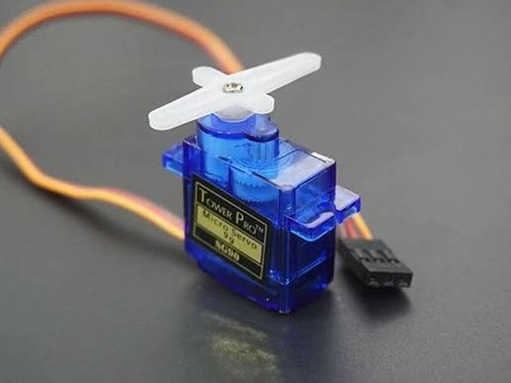
fig 4: MICRO SERVO MOTOR

D.BUZZER

A buzzer is an electronic device that makes a sound. It is used to give alerts or warnings.Buzzers can produce beeps, buzzes, or tones.They usually have two pins: positive and negative.Microcontrollers like Arduino or ESP8266 can control them.Buzzers are used in alarms, timers, and smart systems.They are simple, small, and easy to use in projects.

E. Blynk App

Blynk app is a mobile application used to control and monitor IoT projects from anywhere. It allows users to connect hardware devices like Arduino, ESP8266, and Raspberry Pi through the internet. Using the app, you can
create custom dashboards with buttons, sliders, and graphs. It helps in sending data from sensors to your phone and controlling devices remotely. The app is easy to use and needs no complex coding for setup. Blynk also supports real-time data monitoring and notifications.

ANALYSIS TABLE

Operation Mode | Manual or semi- automated | Fully automated using IoT and  sensors
Human Involvement | High (requires gatekeeper at  site) | Minimal (remotely monitored and  controlled)
Accuracy of Train Detection | Relies on fixed schedule/timing  or personnel | Real-time detection via sensors
Gate Operation Timing | May cause delay or early closure | Accurate gate closure based on real-time train  location
Safety Level | Medium (human error possible) | High (reduced human error, real-  time response)
System Maintenance | Traditional, reactive maintenance | IoT-enabled predictive maintenance  possible
Communication | No or minimal real-time alerts | Real-time alerts via  IoT devices (e.g., SMS/notification)
Traffic  Congestion | Common due to  early gate closure | Reduced due to  smart gate timing
Power Dependence | May rely solely on grid | Can be integrated with solar/backup  systems
Emergency Handling | Slow due to manual response | Faster response  with automated alerts
Cost (Long- Term) | Higher due to  labor and inefficiencies | Lower due to  reduced manpower and automation
Scalability | Limited; depends on manual  infrastructure | High; easily scalable with IoT  networks
Data Logging and Analysis | Rare or manual logs | Automatic logging for analysis and  improvement
Fig 5: Analysis Table

CIRCUIT CONNECTION
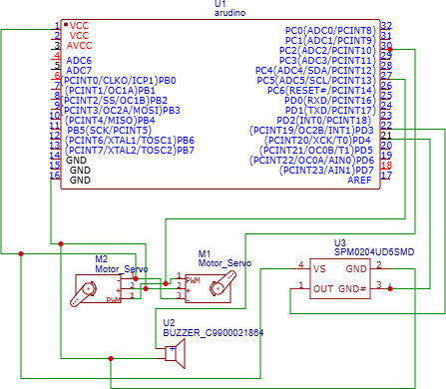
Fig 6: CIRCUIT DIAGRAM

Time(seconds)=Distance(meter)/Speed(m/s) Eg:
Time(s) = 500/36.1 Time(s) = 13.85 seconds
Therefore the Train has 13.85 seconds to reach the gate.

RESULT AND DISCUSSION:

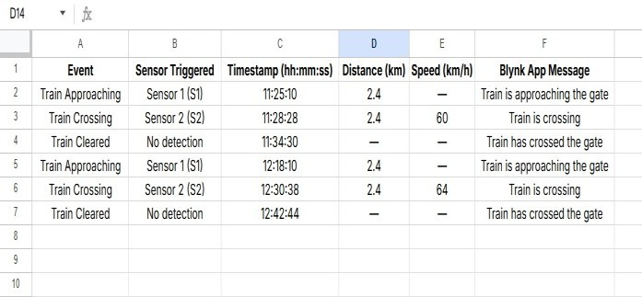
Fig 7: XL SHEET REPORT

In Fig 6, The Smart Railway Gate Control System Using IoT was tested successfully, and the table above shows its working results. The system uses two ultrasonic sensors— Sensor 1 (S1) and Sensor 2 (S2)—placed on either side of the railway track to detect the train's movement. The ESP8266 Wi-Fi module collects the data from these sensors and sends it to the Blynk app, which displays the train's status, speed, and distance in real time.When Sensor 1 detects the train, the app shows the message"Train is approaching the gate", and as it reaches Sensor 2, the status changes to "Train is crossing". After the train completely passes the gate, the app updates to "Train has crossed the gate". During testing, the train was first detected at 11:25:10 and crossed the gate at a speed of 60 km/h, covering a distance of 2.4 km, while the second test showed a speed of
64 km/h. These results clearly prove that the system can accurately detect train movement, send real-time updates through the Blynk app, and ensure safe and automatic gate operation without the need for human control.
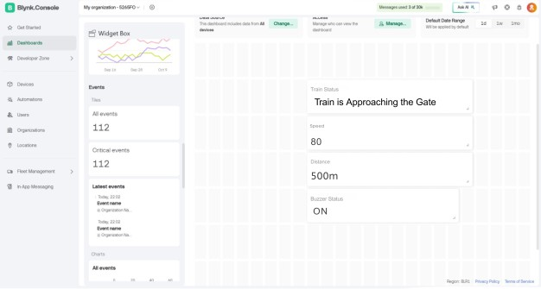
Fig 8: BLYNK APP CONSOLE
In Fig 7,The Smart Railway Gate Control System Using IoT worked successfully during testing. The system uses ultrasonic sensors and an ESP8266 Wi-Fi module to collect and send data to the Blynk app for live monitoring. When a train comes near the gate, the Blynk dashboard shows the message "Train is Approaching the Gate" along with the train’s speed (80 km/h) and distance (500 m). At the same time, the buzzer status changes to ON, which means the warning alarm is active to alert people nearby. After the train completely passes the gate, the buzzer turns OFF, and the app updates to show that the train has safely crossed the gate. This result proves that the system can easily detect the train’s movement, give real-time updates, and control the gate automatically. It is a simple, smart, and safe IoT-based solution that helps prevent accidents and reduces human errors at railway crossings.

CONCLUSION:
This project successfully develops a Smart Railway Gate Control System using IoT to improve safety and reduce human error at level crossings. The system uses ultrasonic sensors placed about 200 meters from the railway gate to detect the arrival and departure of trains. When the sensor detects an approaching train, it automatically sends signals to the Arduino Uno, which then activates the servo motor to close the gate and triggers a buzzer to alert nearby vehicles and pedestrians. The ESP32 Wi-Fi module ensures real-time data transfer and allows monitoring of the gate’s status remotely. This automation reduces manual intervention, minimizes accidents like the Cuddalore train accident, and ensures smoother train movement. Compared to traditional systems, this design offers a more reliable, faster, and cost- effective solution. In the future, additional features such as camera-based detection, GPS tracking, and cloud data logging can be added to further enhance accuracy and public safety.

REFERENCES
- S. Ramesh, M. Ramya, S. Johnpaul, A. Sivabalan, G. Jayant, and M.
Y. Al-Safarini, “Engineering excellence: Fabricating an intelligent and automated railway gate control system,” 2024. [Online]. Available: ResearchGate / Semantic Scholar.
- R. Naik, S. Naik, M. Salunke, C. Chavadi, and B. Jadhav, “Design and implementation of IoT-based automated railway gate crossing system,” 2024. [Online]. Available: Semantic Scholar / ResearchGate.
- K. Pradheep, G. Deepika, G. Mythili, M. Dinesh Kumar, and V. M. Prabhakaran, “Drone-based crop monitoring system for detecting plant diseases,” Int. J. Res. Appl. Sci. Eng. Technol., vol. 22214, 2019.
- S. M. G. Mostafa, N. Sharmily, U. Marzan, T. Sultana, and A. Hossain, “Design and development of an automatic railway gate control system with GSM alert,” 2023. [Online]. Available: Google Scholar / Conference Record.
- M. B. Mahfuz, Z. M. Ali, and M. S. Hossain, “Development of a smart railway system for Bangladesh,” in Proc. TENCON 2017, 2017.
- M. M. Eid and M. I. Fath Allah, “Automated railway security system,” 2019/2020. [Online]. Available: ResearchGate.
- T. Ahmed and I. Chowdhury, “Into the binary world of zero death toll by implementing a sustainable powered automatic railway gate control system,” 2021/2022. [Online]. Available: Semantic Scholar.
- J. Kottnana et al., “Enhancing safety at railway gate crossings using sensors,” in Proc. ICMACC 2024, 2024. [Online]. Available: ResearchGate / Conference Listing.
- K. Gangwar, A. Sarojwal, and P. P. Singh, “A study and solution for unmanned railway crossings with complete automation,” 2024. [Online]. Available: Semantic Scholar / Conference Listing.
- Q. Wu, X. Ge, Q.-L. Han, and Y. Liu, “Adaptive-observer-based sensor fault resilient control for single-phase grid-connected converters in high-speed railway traction systems,” 2023. [Online]. Available: arXiv / Journal Preprints.
- P. Ilampiray, K. Deepak, M. G. D. Santhosh, and S. Kishore, “Design and fabrication of a prototype automated railway gate controller,” 2024/2025. [Online]. Available: ResearchGate / Conference Metadata.
- R. Cobley, The Application of Fault Testing to a Railway Signalling System, 1988.
- P. Pradeep Varna, D. Bhaskar, A. H. M. Anirudha, and V. K. Agrawal, “Solution to unmanned railway crossing using satellite and GPS-based approach,” 2018.
- N. Singh and K. Sinha, “Traffic management system at railway crossings using IoT,” 2023.
- P. Bhowmik, S. Islam, J. K. Sifat, M. S. Mahmud, and F. Faisal, “Design and development of IoT-based automated railway level crossing,” 2023.
- T. A. Selvan, A. Viswanathan, S. Madhankumar, and R. Dhanush Kumar, “IoT-based railway crossing gate status monitoring system,” 2024.A. K. Dewangan, M. Gupta, and P. Patel, “Automation of railway gate control using microcontroller,” 2012.
- R. Pandey and H. V. Haripriya, “Automated railway crossing gate using IoT,” 2022.
- Lakshmi and M. Viji, “Analysis on smart railway gate control using IoT,” 2019.
- G. K. M. Girisha, A. J. Akshaya, A. K. Anjali, and S. Tabassum,
“Solar-powered automatic railway gate control,” 2024.
- M. Amjath and T. Kartheeswaran, “An automated railway level crossing system,” 2020.

